Contents

Trader login with valid details 2

Trader login with invalid details 2

View Dashboard 3

View Order Details 4

View Product Report 5

View Stocks Report 6

Sales Report 7

Sales Report 8

## Trader login with valid details

Expected Result: Trader is successfully logged in after admin approval

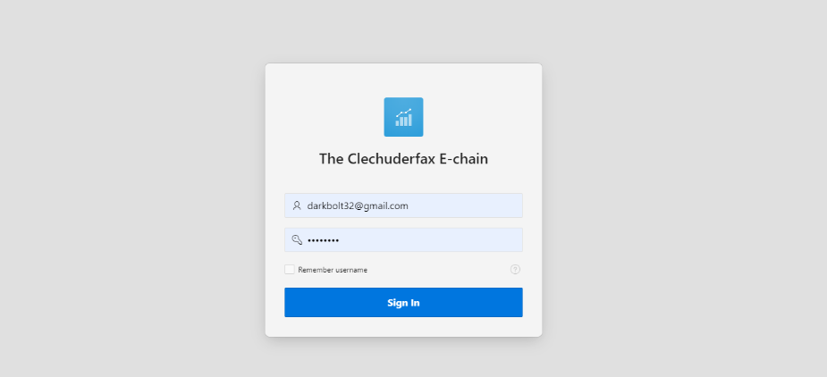

## Trader login with invalid details

Expected Result: Access denied

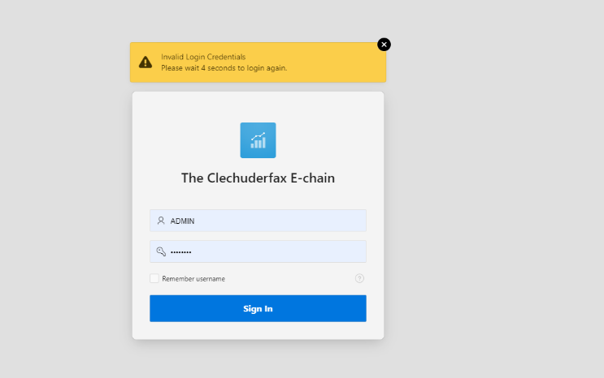

## View Dashboard

Expected Result: Traders can view dashboard with summary

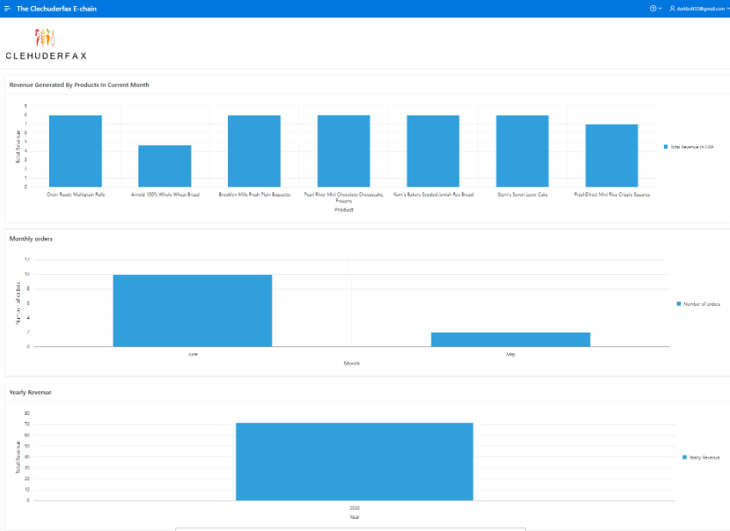

## View Order Details

Expected Result: Traders can view a report of orders for the day.

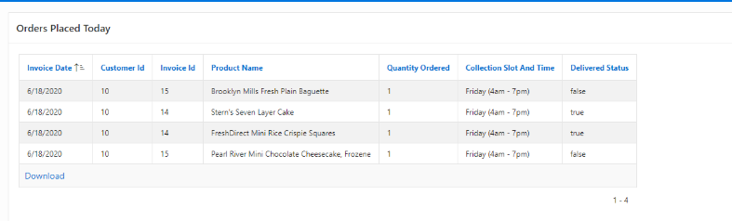

## View Product Report

Expected Result: Trader can view shop, products, and their details

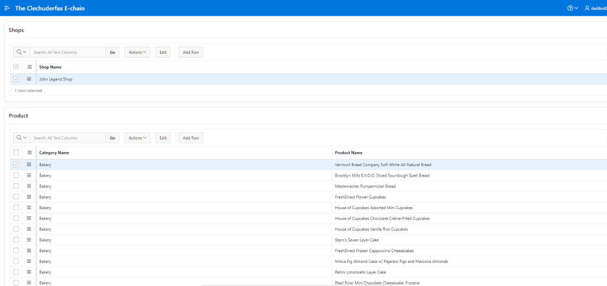

## View Stocks Report

Expected Result: Trader can view and update stocks with this report

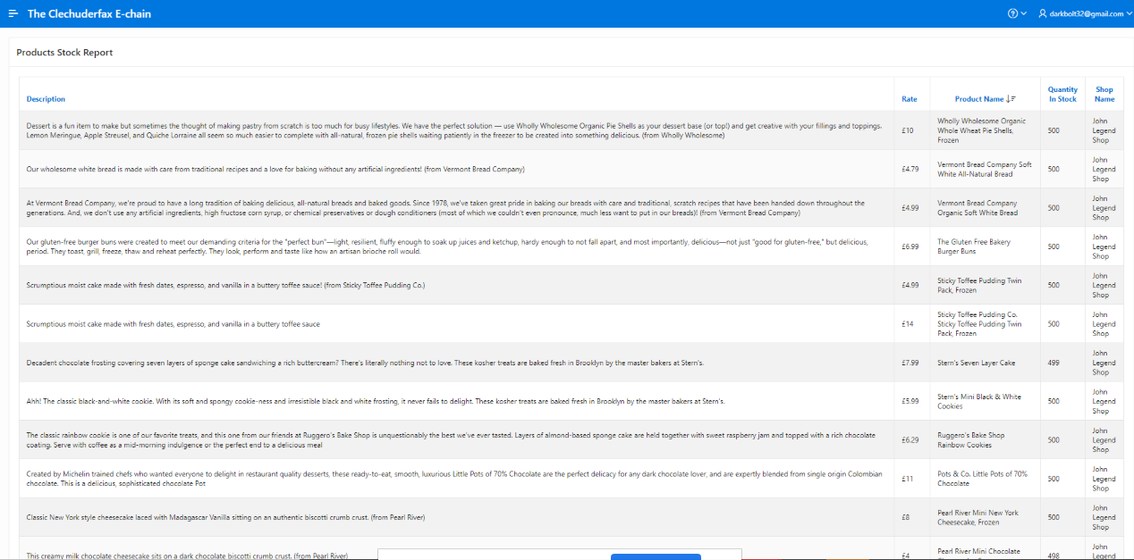

## Sales Report

Expected Result: Trader can see all the sales report, Total Income Per Product of products which can be sorted as required

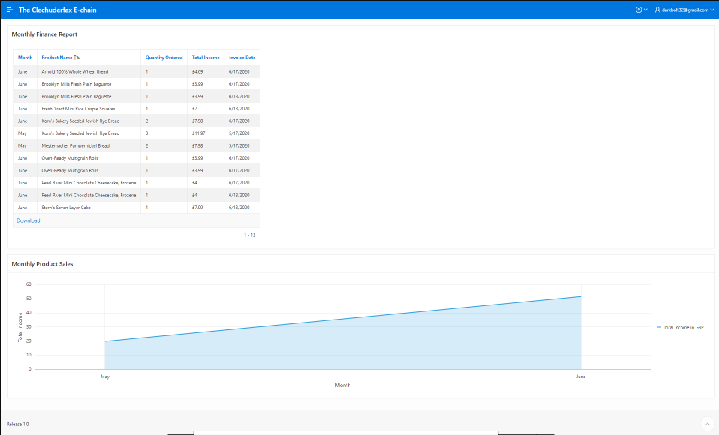

## Sales Report

Expected Result: Trader can see all the Weekly sales report

